2023 CREEKVIEW ATHLeTiCS  SUMMER STRENgth & cONDITIONING WORKOUTS and Skills Sessions  WHEN:  May 30 – June 2 JULY 10-13  JUNE 5-8 July 24-27  JUNE 12-15  JUNE 19-23  June 26 -29  Times:  Strength & Conditioning Sessions:  Session 1: 7:00 am – 9:00 am (High School)  Session 2: 11:00 am – 1:00 pm (incoming 9th – 7th Graders)  Sport Skills Session  9:15 am – 10:00 am - Volleyball (Gym) / Football (field)  10:15 am – 11:00 am (Boys-Girls) Basketball / (Boys-Girls) Soccer / Baseball-Softball  WHERE:  Creekview High School  3201 Old Denton Rd. Carrollton Tx, 75007  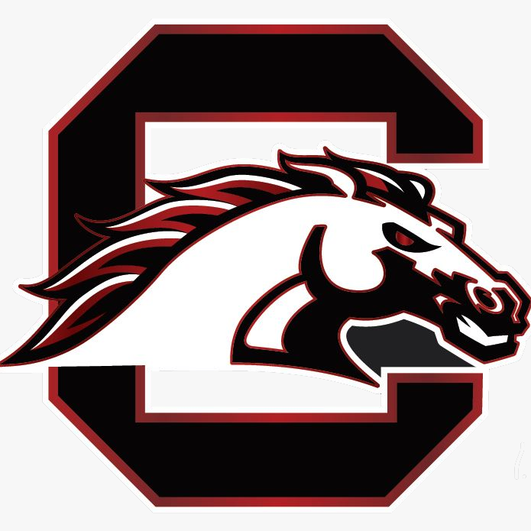 | Grades Levels:  High schools  7th & 8th graders  Free  F.A.S.T  Foundation  All-In  Selfless  Toughness  Sports Coached BY  All Creekview Coaches.  Benefiting  All Creekview Students Present and Future Mustangs

